Question 2

**Candidate Number: 59069**

Artificial Intelligence - CS3AI18

horizontal line

# 

## 

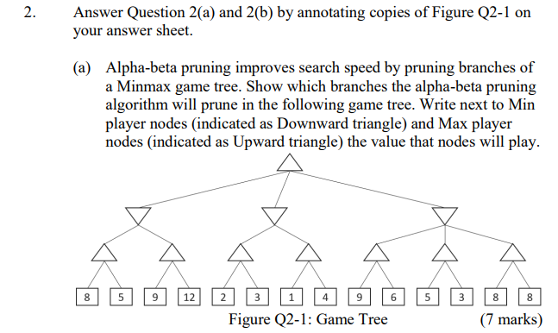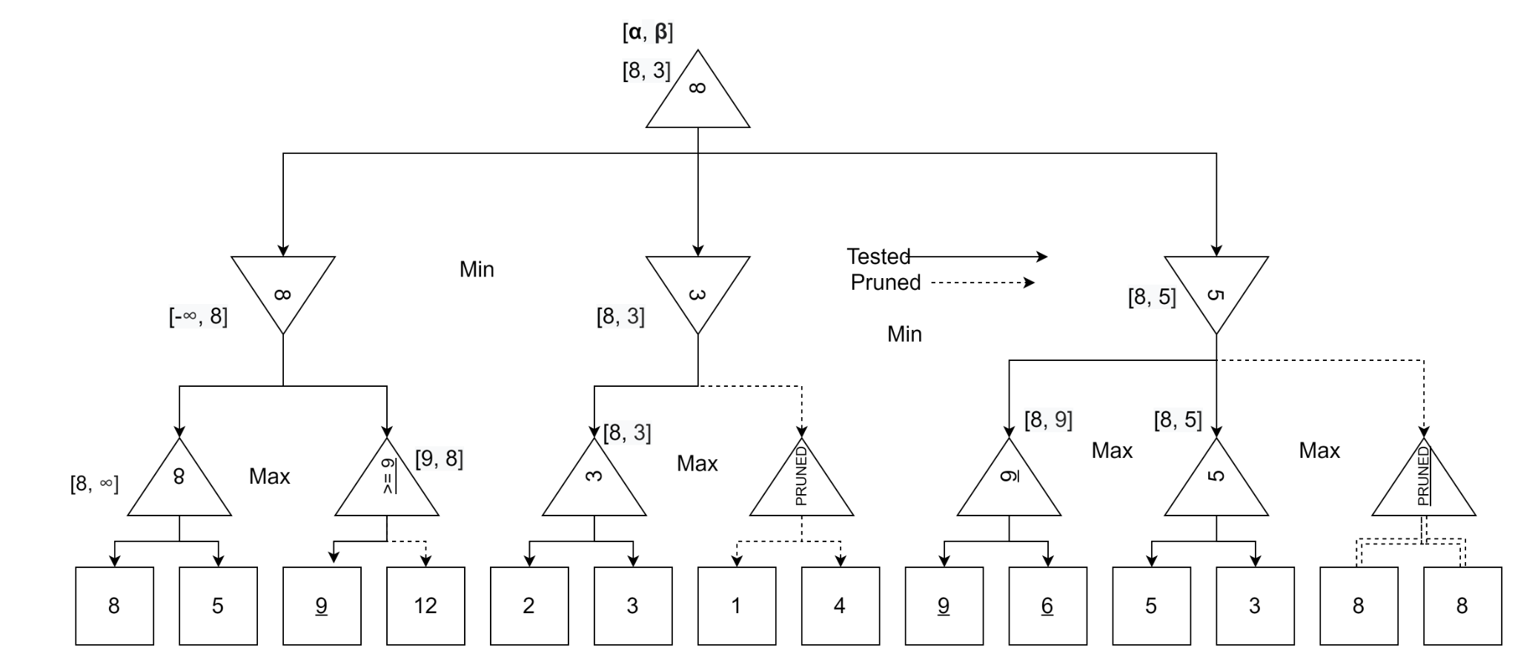

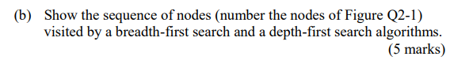

Assume start node == node 0

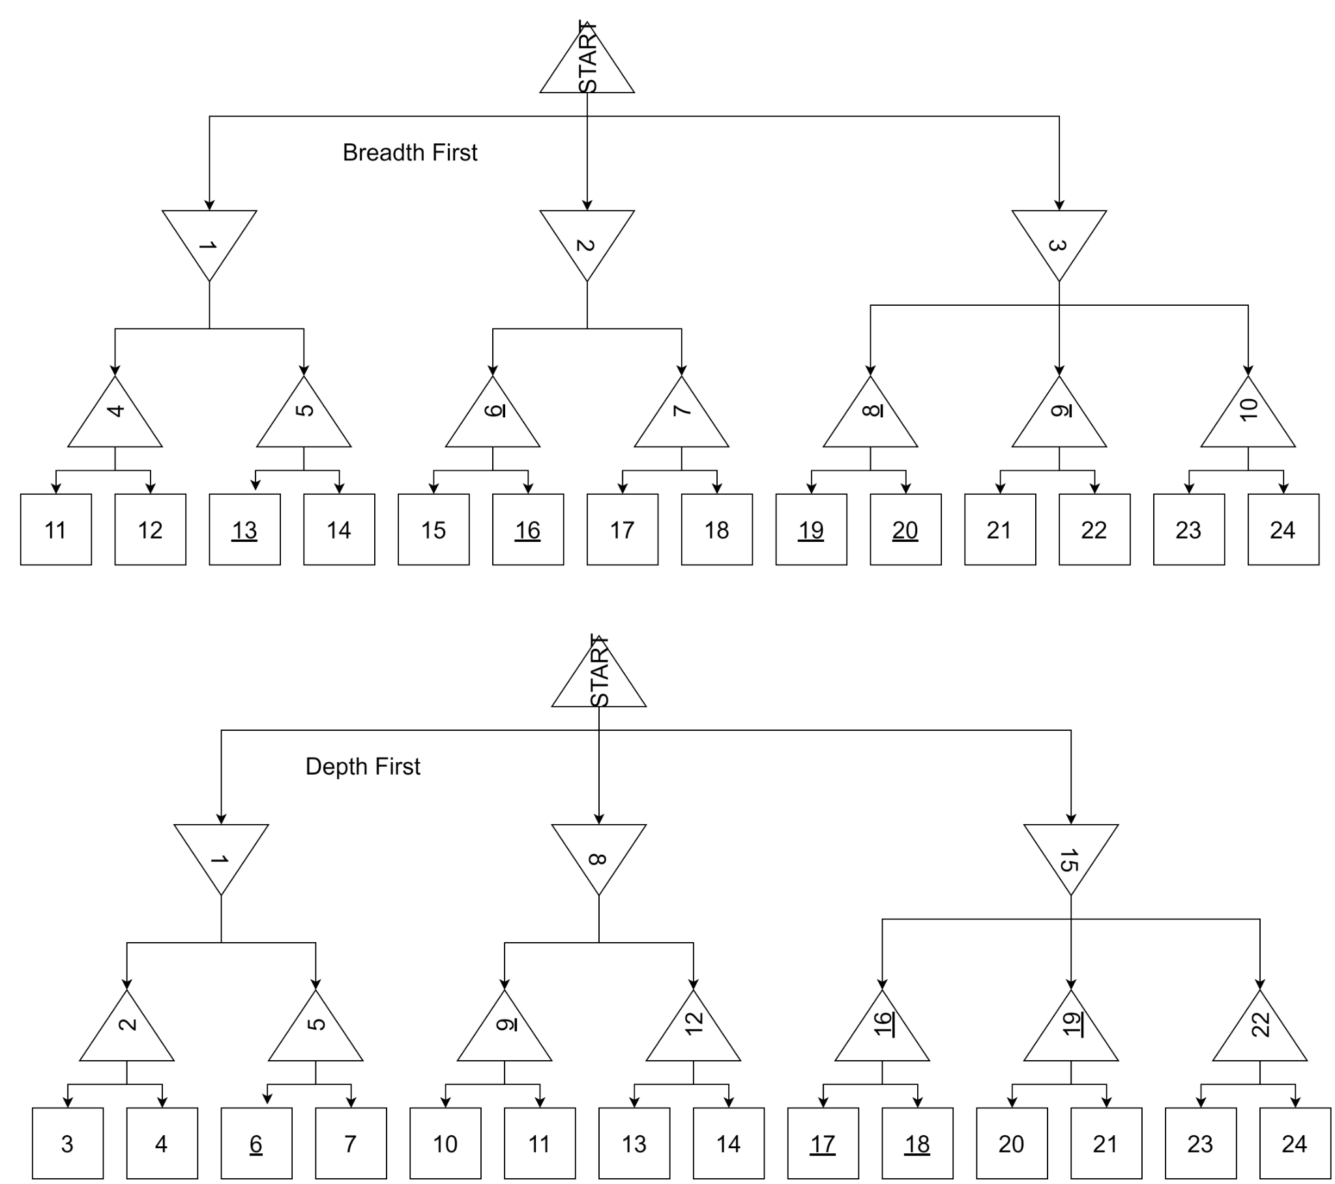

2C:

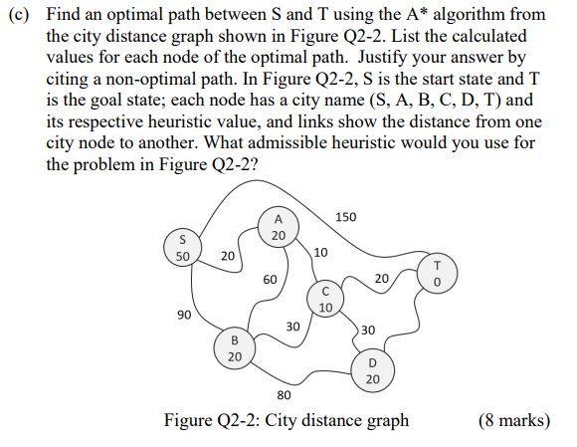

Respective heuristic value is used as H

Start At **S**

**S → A = 20 + H(20) = 40**

S → B = 90 + H(20) = 110

S → T = 150 =H(0) = 150

(S→)A → B = 20 + 60 + H(20) = 100

**(S → )A → C = 20 + 10 + H(10) = 40**

(S → A →) C → B = 20 + 10 + 30 + H(20) = 80

(S → A → )C → D = 20 + 10 + 30 + H(20) = 80

**(S → A → ) C → T = 20 + 10 + 20 +H(0) = 50**

Shortest path from S → T

**S → A → C → T = 50**

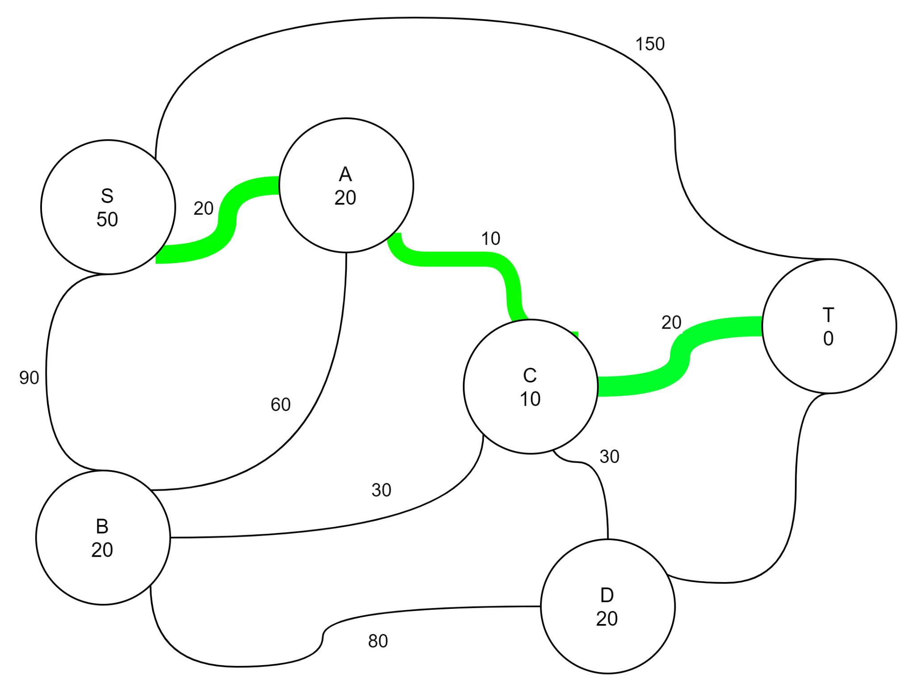

A non-optimal solution would be directly from **S → T** with a length of **150**.

An admissible heuristic is one that never overestimates the cost of reaching the goal. The heuristic used for this appears to be directly related to the distance from T.

It is most likely representing a straight line to the point. This is a very good heuristic to use for this problem.